36.50: a) For dark spots, 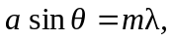so 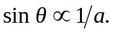 Heating the sheet causes the slit width to increase due to thermal expansion, so 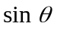and hence will decrease. Therefore the bright region gets narrower.
b) At the lower temperature:
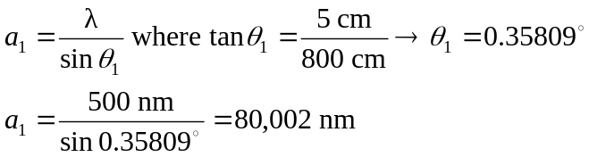
At the higher temperature:
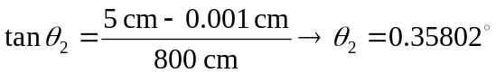
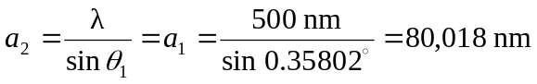
Thermal expansion: 